**Delta Airline Departure Data**

In this exercise, you will be looking at Delta Airline departure data from 11/22/2013 thru 11/30/2013 from Cincinnati (CVG) and from the five busiest airport in the United States.

1. Download the excel file Delta_Data and save it in your current directory for MATLAB.
2. Create a script file. At the top of your script file, add comment lines that include your name and the date.
3. Add the dataset command to your script file to create a dataset array in MATLAB from the excel file:

F = dataset('xlsfile','Lab3_Delta');

1. Run your script file. Double click on F in the Workspace Window to open it up in the Variable Editor Window. You should see something like the following:

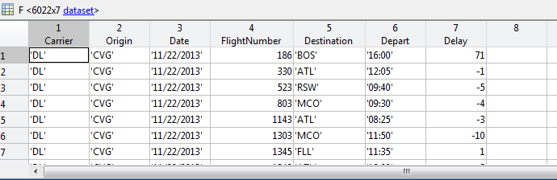

* F.Carrier is ‘DL’ for the entire dataset (Delta)
* F.Origin is a cell array of the airport the flight departed from. There are six airports included:
  + ‘CVG’ (Cincinnati)
  + ‘ATL’ (Atlanta)
  + ‘ORD’ (Chicago),
  + ‘LAX’ (Los Angeles)
  + ‘MIA’ (Miami)
  + ‘DFW’ (Dallas-Fort Worth)
* F.Date is a cell array of dates ranging from 11/22/2013 thru 11/30/2013
* F.FlightNumber is a vector of flight numbers
* F. Destination is a cell array of destination airport codes
* F. Depart is a cell array with scheduled departure times using a military clock
* F.Delay is a vector of numbers with the departure delay in minutes

**A. Pie Chart**

1. Add commands to your script file that will calculate the percentage of the total flights leaving each airport (what percent of the total flights departed from CVG, what percent of the total flights departed from ATL, …). **DO NOT Scroll through the dataset in the Variable Editor Window to find these numbers. Use MATLAB commands in your script file to determine these values.**
2. Now create a pie chart showing the percentage of the total flights leaving from each of the six airports. Your pie chart should include a ***title*** and a ***legend***.

**PASTE PIE CHART HERE:**

**B. Airport Departure Statistics**

1. Find the average delay, standard deviation, maximum delay, and minimum delay for the entire data set and enter the results in the first row of the table below.
2. Add a **for** loop to your script file that will allow you to compute the statistics for each airport

In order to complete the following table.

*Hint: Look at the script file in Lecture 3 for creating the bar chart. Create a cell array with the six airport origin codes. In your loop, create a vector for the mean, a vector for the standard deviation, a vector for the maximum delay, and a vector for the minimum delay. After completing the loop, display each vector and fill out the table.*

|  |  |  |  |  |
| --- | --- | --- | --- | --- |
| **Origin Airport** | **Mean Delay (min)** | **Standard Deviation (min)** | **Max Delay (min)** | **Min Delay (min)** |
| **Overall** |  |  |  |  |
| **CVG** |  |  |  |  |
| **ATL** |  |  |  |  |
| **ORD** |  |  |  |  |
| **LAX** |  |  |  |  |
| **MIA** |  |  |  |  |
| **DFW** |  |  |  |  |

1. Which airport has the most variance in terms of flight delays?
2. Based on the values in the table, how did CVG compare with the other airports?
3. What percentage of flights out of CVG had a delay time that exceeded the ***overall mean*** delay? Note: Can use Command Window or script file for this part.
4. What percentage of flights out of CVG had a delay time that was more than one standard deviation above the ***overall mean*** delay? Note: Can use Command Window or script file for this part.

**C. Bar Chart: Mean Delay by Date and Airport**

1. In your script file, compute the ***mean delay*** from each airport on each of the following dates: 11/26/2013, 11/27/2013, 11/28/2013, 11/29/2013, and 11/30/2013. These delays should be stored in a 5 x 6 matrix. Each ***row*** of the matrix corresponds to a ***date*** and each ***column*** of the matrix corresponds to an ***airport***.

*Hint: Nested For Loop with one loop going through airports and one loop going through dates.*

1. Now use the bar command to create a bar chart:

* The mean delay time should be on the y-axis
* The dates should be on the x-axis
* Include a legend with the airports
* Include a title
* Include a label on the y-axis

**PASTE PLOT HERE:**

3. Based on your chart, what are the best days to travel around Thanksgiving?

(Note: Thanksgiving was November 28th this year).

4. What airport appeared to perform the best during the two days prior to Thanksgiving?